Telecommunicaitons MANAGEMENT– 95-705K
Assignment 4 (due 11 November 2014)
- A GSM operator (2x10 MHz of frequency allocation, operating frequency in the uplink 780-790 MHz, Downlink 850-860 MHz, carrier bandwidth = 200 kHz, 8 TDMA users per carrier, re-use factor = 3) is to operate a mobile communications system in Adelaide. The expected customer base density is 1500 subscribers per km², who each expect to generate on average 0.1 Erlang at peak times. Assume system parameters as: GoS: 1%
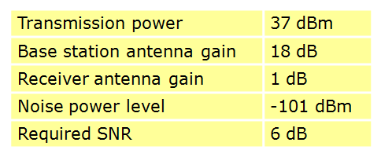
- What path loss model should be used?
L(Hata)=26+35log(d)+34log(f)+10log(f/2000)
- What is the maximum range of this system according to your model?

37dBm+18dB+1dB-L = -101dBm+6dB
L=151dB
151 = 26+35log(d)+34log(860)+10log(860/2000)
d=6.7km
- You are the network design manager responsible for deciding how many base stations must be built within Adelaide central area. (Assume a circular area with a radius of 5 km.) Explain, and calculate the steps you must take in arriving at this decision. Hint: you will need to find the required radius of each cell, and the number of subscribers which can be served.
10MHz/3/200kHz*8=133.33
Total Erlang=(1500*0.1)=150, GoS=1%, so Lines required is 170.
5*5*pi*(170/133.33)=100
100 stations are needed.
(50 points)
- Explain what the differences between a noise limited system and an interference limited system are using one example for each system.
(20 points)
When the noise is much larger than the interference, the system is noise limited and when interference is much larger than the noise, it is interference limited.
FDMA use different frequency for different base station so it is noise limited rather than interference limited.
CDMA use same frequency for different base station so it is interference limited.
- Explain:
- Why is the cell re-use factor smaller for TDMA (2G) systems than FDMA (1G) systems?
Because TDMA is based on digital communication and the Signal to interference ratio requirements is lower.
- Why CDMA uses a cell re-use factor of one?
Because CDMA multiple mobile stations served by a base station are distinguished by their unique codes, using a spread spectrum technology. Thus different base stations can use the same frequency and the re-use factor is one.
- What are the sources of interference for a OFDMA system?
Other users and other mobile/base stations
(30 points)

